

Care Data Exchange v1.3
User Interface Layout & Design
Draft Document Version 1.0
Prepared by J. Mangione
Prepared for Internal
Version Released 28-Jan-02
Document Status Draft
Document Code: PROD-SRS0000-VVV.vvv
Document Location /tmp/lo/0000.doc
Notice: This information is proprietary to CareScience, Inc. As such, it is privileged, confidential and exempt from disclosure under applicable law. Any unauthorized use, duplication, or assimilation of this information is strictly prohibited.
This information is proprietary to CareScience, Inc. As such, it is privileged, confidential and exempt from disclosure under applicable law. Any unauthorized use, duplication, or assimilation of this information is strictly prohibited.

Any use of the Material is governed by the terms of the actual license agreement between CareScience and the user. Any reproduction or redistribution, by any means – whether mechanical or electronic – without the express written permission of CareScience is strictly prohibited. The Material includes information protected by copyrights and/or patents held by CareScience.
It is understood by users of this Material that the information contained herein is intended to serve as a guide and basis for general comparisons only, and NOT as the sole basis upon which any specific action is to be recommended or undertaken. All users of this document agree to hold CareScience harmless from any and all claims, losses, damages, obligations or liabilities, directly or indirectly relating to these materials, caused thereby or arising therefrom.
CareScience assumes no responsibility for errors or omissions in these materials. CareScience does not warrant the accuracy or completeness of the information, text, graphics, links or other items contained within these materials. CareScience shall not be liable for any special, indirect, incidental, or consequential damages, including without limitation, lost revenues or lost profits, which may result from the use of these materials. CareScience may make changes to these materials, or to the products described therein, at any time without notice.
THESE MATERIALS ARE PROVIDED “AS IS” WITHOUT WARRANTY OF ANY KIND, EITHER EXPRESS OR IMPLIED, INCLUDING BUT NOT LIMITED TO, THE IMPLIED WARRANTIES OF MERCHANTABILITY, FITNESS FOR A PARTICULAR PURPOSE, OR NON-INFRINGEMENT. THE DOCUMENTS AND RELATED GRAPHICS PUBLISHED IN THIS DOCUMENT COULD INCLUDE TECHNICAL INACCURACIES OR TYPOGRAPHICAL ERRORS. CHANGES ARE PERIODICALLY ADDED TO THE MATERIAL HEREIN. CARESCIENCE AND/OR ITS SUPPLIERS MAY MAKE IMPROVEMENTS AND/OR CHANGES IN THE PRODUCT(S) AND/OR PROGRAM(S) DESCRIBED HEREIN AT ANY TIME.
Copyright © 1998-2001 CareScience, Inc., 3600 Market Street, 6th Floor, Philadelphia, PA, 19104, U.S.A. All Rights Reserved.
PROD-SRS0000-VVV.vvv

Table Of Contents
1. Scope Of Document 4
1.1 References 4
1.2 Requirements To Be Met 4
1.3 Assumptions and Constraints 4
2. Patient Results 5
2.1 Find Patients 6
5.2 Find Patients → Patient List Details 7
2.2 Find Patients → Patient Candidates 8
2.3 Find Patient → Result Types 9
2.4 Find Patients → Patient Results 12

Scope Of Document

This document will define the screen layout modifications for v1.3 of the Care Data Exchange, and their design changes.

Shown are the v2.0 screens, which will be used as mockup’s for how the v1.3 will be layed out. Branding will remain unchanged for this release.

References

Requirements To Be Met

- Additional Result Types will be added as tabs to the result screen.
> Selecting individual result types will be applied for all patients selected in the case more then one is choosen.
- Patient Lists will be displayed as part of the initial Find Patient screen. This will also involve additional logic to display demographic information of those patients, removing patients from list.
- Selection Of Multiple Patients when selecting from the Patient Candidate List.
- View Patient Results will display a listbox allowing selection of a single patient at a time.

Assumptions and Constraints

- Existing architecture will be used, with improvements to modules as time permits.
- Bi-Directional CERT functionality will remain intact and will not change for logging in.

Patient Results

The following sections will layout the new enhancements requested. These are mockup’s based on the new v2.0 UI which is not being implemented now due to time-to-market constraints.

The layouts will depict what fields are where, and show relative placement of controls where applicable. Menu’s and non-v1.3 features will not be implemented at this time.

A NOTES on v1.3 will detail out specific features/functions where the layout of v2.0 deviates from the actual implementation for 1.3.

Find Patients

This is the default screen shown after login.

Notes On v1.3
- Due to the current architecture, Find All Results will not be implemented. Result Types will default to ALL unless user specifies individually.
- Advanced Result Search is equivalent to SEARCH.

Navigation
- Patient List Details goes directoy to Patient List Details and describes each patient’s demographic data, similar to the Patient Candidate.
- Advanced Result Search (SEARCH) allows the user to select individual result types prior to finding the results.
- Find Patients (SEARCH) queries the ICS for patients that match criteria entered. Displays the Patient Candidates list that users to choose from.

Implementation Notes
- At user login, a call to an interface class that queries the LDAP directory, will return ***WHAT FORMAT*** the patient list to be loaded.

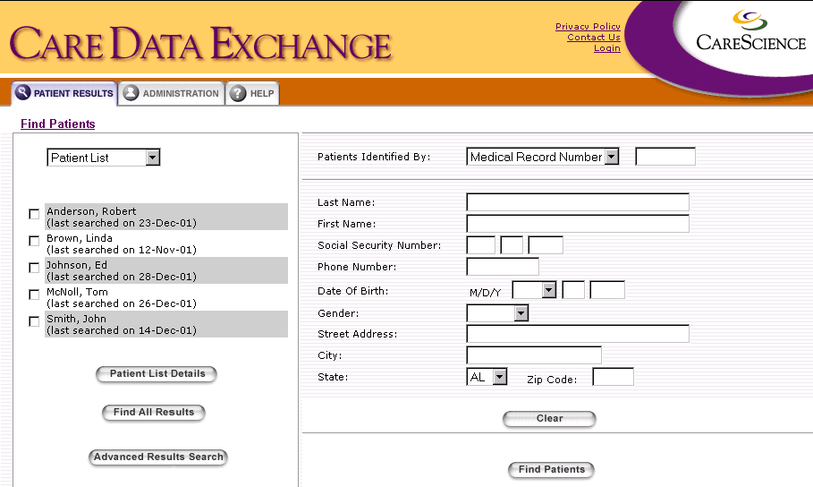

5.2 Find Patients → Patient List Details

Displays demographic information per Patient in the Patient List. Allows users to delete patients from the list or select individual patients to retrieve results for.

Notes on v1.3
- Due to the current architecture, Find All Results will not be implemented. Result Types will default to ALL unless user specifies individually.
- Advanced Result Search is equivalent to SEARCH.

Navigation
- Remove From List will delete a particular patient and redisplay list.
- Advanced Result Search (SEARCH) allows the user to select individual result types prior to finding the results.
- Return To Find Patients (TBD) will return to the original query screen.

Implementation Notes
- Will need to query ICS??? to obtain this information??? Passing Patient ID’s retrieved from LDAP?
- Remove From List will refresh this page. On returning to the first page, a new call should be made to the LDAP class to retrieve the updated list.

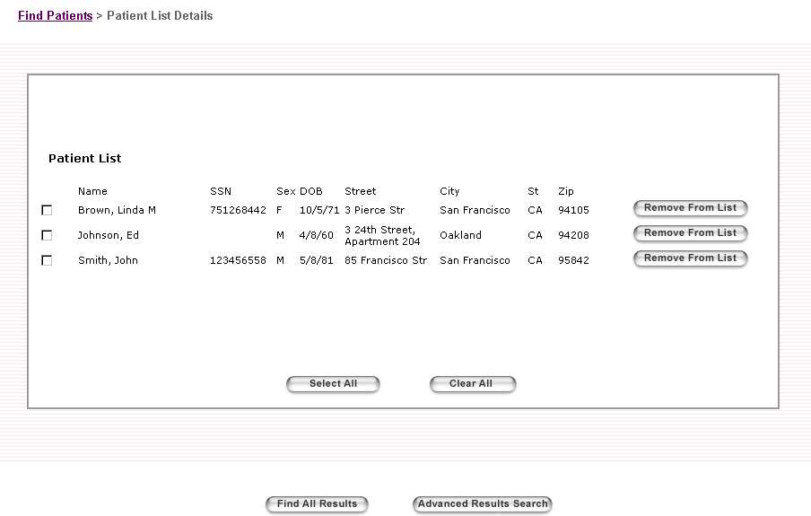

Find Patients → Patient Candidates

Displays all patients found based on the criteria entered in Find Patients, along with demographic information, and aliases.

Notes on v1.3
- Due to the current architecture, Find All Results will not be implemented. Result Types will default to ALL unless user specifies individually.
- Advanced Result Search is equivalent to SEARCH.

Navigation
- Advanced Result Search (SEARCH) allows the user to select individual result types prior to finding the results.
- Return To Find Patients (TBD) will return to the original query screen.

Implementation Notes
- Functions similar to current v1.2, only allowing the selection of multiple patients. Note also that expand/collapse should be implemented for aliases (this is already in v1.2).

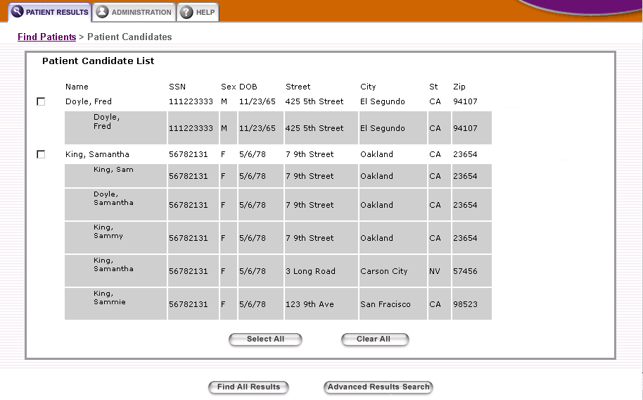

Find Patient → Result Types

This page can be accessed from either the Patient List or Candidate List (querying). It is designed as a single page with individual sections as anchors, with the option to Find Selected Results per section.

The list of patients being searched will appear at the top of this screen.

Notes on v1.3
- What are shown as individual tabs/anchors for result types (lab, radiology, etc…) will take on the current v1.3 look and feel.
- Header needs to remain consistant throughout result types. Only body of Result Class will flip between types.

Navigation
- Patient Candidates (or Patient List) returns back to the list the user previously came from.
- Find Selected Results goes to the Patient Results screen displaying only those results types selected in this screen.
- Individual Result Type links (Laboratory, Radiology, etc…) will link to that section in this page. These are not framed.

Implementation Notes
- TBD

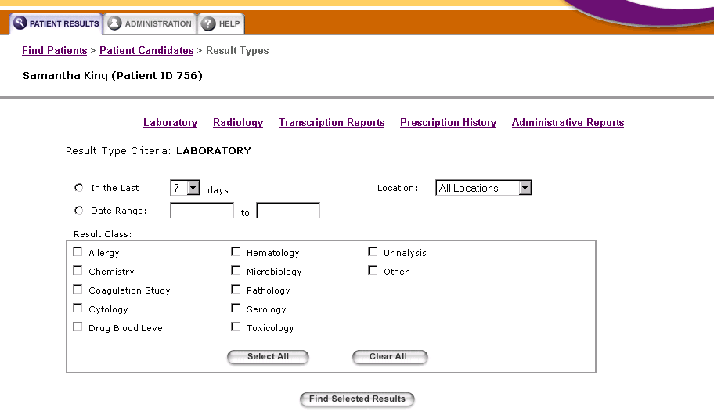

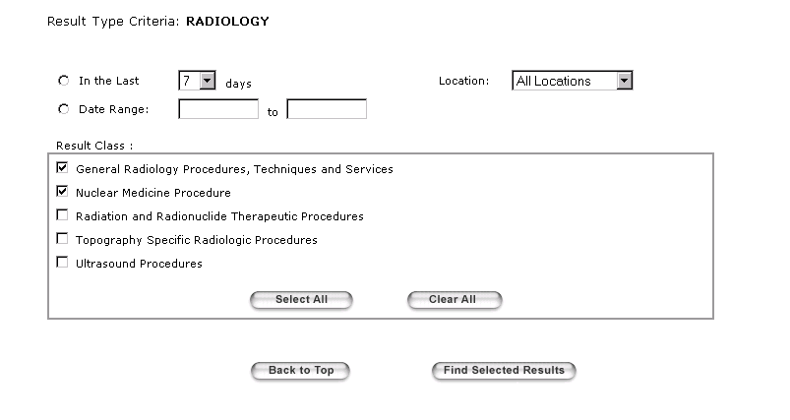

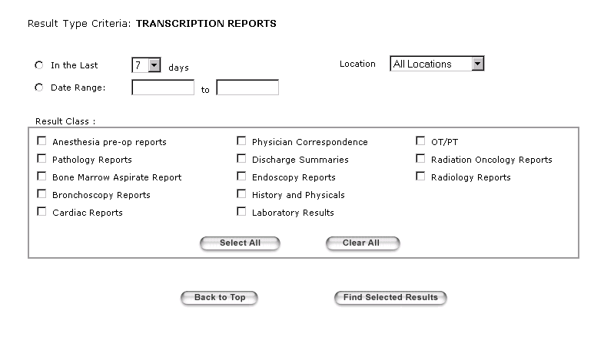
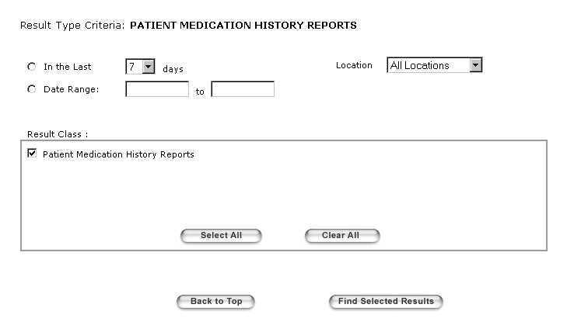

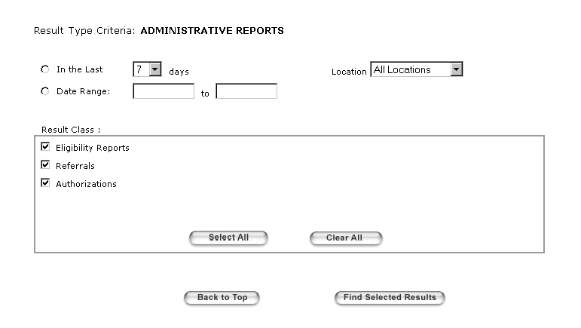

Find Patients → Patient Results

This screen displays the results of one or more patients after a Select All Results or Advanced Result Search was performed.

Notes on v1.3
- Checkboxes will not be shown. Functionality for viewing multiple results will be defered for this release.
- There will be a listbox with patient names that will only display results for a particular patient at one time. This eliminates the need to display Patient Name as a column.
- The current SITE and LINK columns will be merged into a single Location (URL) column.

Navigation
- Advanced Result Search (SEARCH) allows the user to select different result types then return to this screen after a new query.
- Individual URL’s can be selected to view a single result. A separate window will pop-up with that result only. No View Results window is required.

